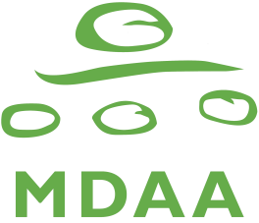
Multicultural Disability Advocacy Association of NSW Inc.
PO Box 884 Granville NSW 2142
10-12 Hutchinson St Granville
Telephone: (02) 9891 6400
Toll Free: 1800 629 072
Facsimile: (02) 9897 9402
E-mail: mdaa@mdaa.org.au
ABN: 60 737 946 674

CALL for Nominations for Positions on the Governance Committee

There are 4 vacancies for Governance Committee Members

                - You have to be a financial Ordinary Member, Family/Carer member or Skilled member of MDAA to nominate for these positions. Please read the enclosed nomination information before making a decision. If you decide to nominate you may need to attend at least one meeting per month. If you are interested in nominating yourself, please fill out this Nomination Form. Two people who are members of MDAA must endorse your nomination. If you have any questions, please call the MDAA Office.

I, (Name) _______________________________________________________________,

(Address) ________________________________________________________________

(Phone No.) ______________________ would like to nominate for the position of:

- Governance Committee member

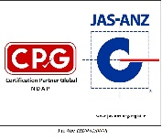
Signature: __________________________ Date: ______________________

1. Supporter (this has to also be a financial member of MDAA)

I, (Name) ______________________________________________________________,
(Address) ______________________________________________________________,
(Phone No.) ______________________ support the above nomination.

Signature: __________________________ Date: ____________________________

2. Supporter (this has to also be a financial member of MDAA)

I, (Name) _______________________________________________________________,
(Address) _______________________________________________________________,
(Phone No.) ______________________ support the above nomination.

Signature: __________________________ Date: ____________________________

You need to return this Nomination Form to MDAA at the above address by:
5 pm on 30 November 2022.

